

Data Analysis Using Python

(Winter School Project)
January, 2018

Data Analysis on Diseases

Group Members:

Soham Banerjee, RCCIIT, 171170110221
Soumyajyoti Das, RCCIIT, 171170110226
Sourav Sarkar, RCCIIT, 171170110229
Biswadip Dawn, RCCIIT, 171170110271
Rohit Basu, RCCIIT, 171170110323
Subhajit Das, RCCIIT, 171170110354

Table of Contents

1. Acknowledgement

2. Project Objective

3. Project Scope

4. Data Description

5. Data loading

6. Interpreting the data

7. Distribution analysis

8. Data cleaning and munging

9. Analysing the data based on various parameters

10. Drawing inferences based on data analysis

11. Future Scope of Improvements

12. Project Certificate

Acknowledgement

We take this opportunity to express our profound gratitude and deep regards to our faculty Mr. Kaushik Ghosh for his exemplary guidance, monitoring and constant encouragement throughout the course of this project. The blessing, help and guidance given by him from time to time shall carry us a long way in the journey of life on which we are about to embark.

We are obliged to our fellow project team members for the valuable information provided by them in their respective fields. We are grateful for their cooperation during the period of our assignment.

Soham Banerjee
Soumyajyoti Das
Sourav Sarkar
Biswadip Dawn
Rohit Basu
Subhajit Das

Project Objective

The main objective of this project is to interpret and analyse given datasets in the field of disease and healthcare. We would try to gain valuable insights and understand trends in the datasets by using python as a tool for data manipulation and analysis.

Project Scope

In this project we used numpy, pandas and matplotlib for data analysis. We focused on data analysis and interpretation using series and dataframes. The following libraries were imported for the project:

import re
import numpy as np
import matplotlib.pyplot as plt
import pandas as pd
import math

Data Description

The entire data is divided into 3 datasets.

1. Symptom Data:
Contains two columns - ‘did’ and ‘diagnose’, and 272 rows.

2. Diagnosis Data:
Contains 2 columns - ‘syd’ and ‘symptom’, and 1166 rows.

3. Symptom vs Diagnosis Data:
Contains 3 columns - ‘did’, ’syd’ and ‘wei’, and 5569 rows.

Data Loading

The data was provided in 3 different .csv files.

For operating and manipulating the data in those files we had to store them in some python data structure.

Hence, the data was loaded into 3 separate dataframes using the pandas read_csv function.

df = pd.read_csv("diffsydiw.csv")
dia = pd.read_csv("dia_t.csv")
sym = pd.read_csv("sym_t.csv")

Using dataframes we can perform various tasks like grouping, plotting and sorting the data.

Interpreting the Data

There were 3 datasets for the given task.

1. Symptom Dataset:

It contains 2 rows - ‘symptom id’ and ‘symptom’. The ‘symptom id’ is a unique number representing each symptom. The symptom column contains the names of the symptoms. The symptom id consists of 272 numbers within the range of 1 to 306.

2. Diagnosis Dataset:

It contains 2 rows - ‘diagnosis id’ and ‘diagnose’. The ‘diagnosis id’ is a unique number representing each diagnosis. The diagnosis column contains the names of the various diagnoses. The diagnosis id consists of 1166 numbers within the range of 1 to 1537.

3. Symptom vs Diagnosis Dataset:

It contains 3 rows - ‘symptom id’, ‘diagnosis id’ and ‘weight’. It provides a correspondence map for each symptom and diagnosis, along with their respective weights.

A few points that we noted:

1. A symptom may have different weight based on the corresponding diagnosis.

2. A disease (diagnosis) may have different weight based on the corresponding symptom.

Distribution Analysis

The data provided to us was not quantitative in nature. Hence, distribution analysis of the data did not yield any significant result. No outliers or odd data bits were found.

df.boxplot()

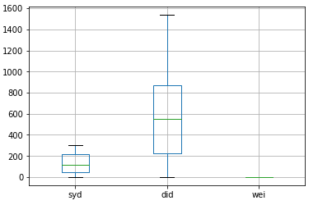

Data Cleaning and munging

While dealing with the given datasets 5 problems arose.

1. Missing values in the symptom dataset.
2. Missing values in the symptom vs diagnose dataset.
3. Dirty data in the diagnose dataset.
4. Improper column nomenclature in the datasets.
5. Improper nomenclature of the elements of the ‘wei’ column.

The problems were dealt with in the following ways.

1. The missing values in the ‘symptom’ column was replaced by the word ‘unnamed’. It implies that the symptom was discovered but not named.

The following code was used:

sym['symptom'] = sym.apply(lambda x: x['symptom']\
if type(x['symptom'])==str else 'unnamed',axis=1)
The head(40) data before replacement was:

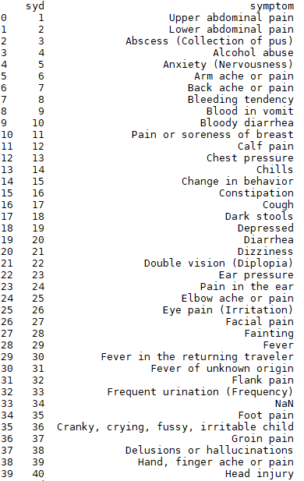
The head(40) data after replacement operation is:

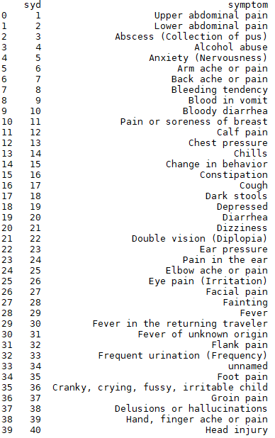

2. The missing values in the ‘wei’ column of the ‘Symptom vs Disease’ dataset fell under two categories.
i. Missing or NaN values.
ii. Zeroes
To overcome the difficulty of dealing with both the cases separately, we filled all the NaN values with 0.

df = df.fillna(0)

After that we grouped the ‘Symptom vs Disease’ dataset by the ‘did’. Here, ‘did’ stands for ‘disease id’ or ‘diagnosis id’.
Now we would look for the ‘wei’ values for a particular disease.
There can be three possible cases:

i. All the values are 0.
ii. Some of the values are 0 and some non-zero.
iii. All the values are non-zero.

In case of all zeroes(i) we will replace all the zeroes with 2. (We will assume it to be life threatening.)
In case of some zero and some non-zero (ii) values the zeroes are replaced by the ceiling value of the mean of all the non-zero values.
In case (iii) no values will be replaced.

def change(x):
grp = df.groupby('did')
temp = grp.get_group(x)
m = temp['wei'].mean()
if m==0:
return 2
else:
return math.ceil(m)
df['wei'] = df.apply(lambda x : change(x['did']) if x['wei']==0 else x['wei']\
,axis=1)

head(40) data before replacement: head(40) data after replacement:
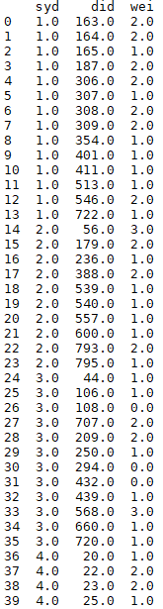
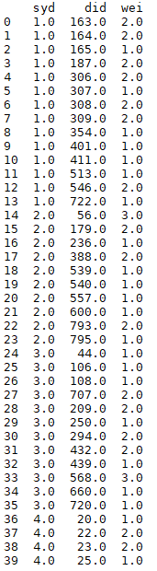

3. The data elements in the ‘diagnose’ column of the diagnosis dataset contain a dirty bit. It is the male symbol (‘♂’) that appears as an unwanted bit in every instance of the diagnose column.

The data before correction:

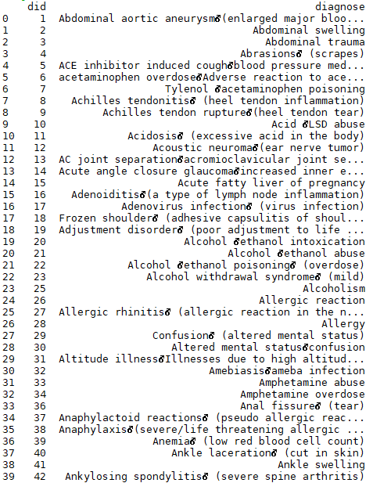

def repair(i):
l = i.split('\x0b')
s = ""
for j in l:
s = s+' '+j
return s
dia['diagnose'] = dia['diagnose'].apply(lambda x: repair(x))

The data after correction:

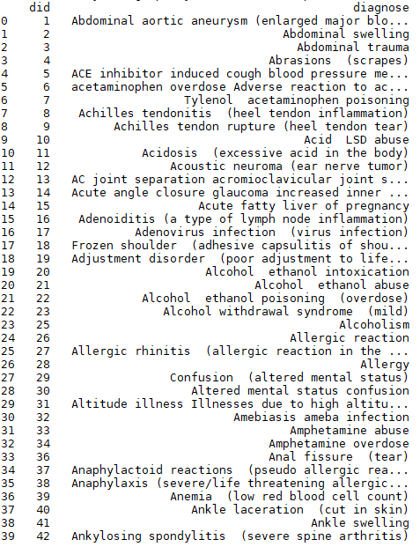

4. The column names in the given datasets were mostly cryptic and meaningless. Hence we changed the names like ‘syd’, ‘did’, and ‘wei’ to ‘symptom id’, diagnosis id’, and ‘weight’ respectively.

The data before correction:

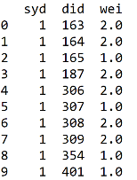

df.rename(columns={'wei':'weight','syd':'symptom id','did':'diagnosis id'}\
,inplace=True)
sym.rename(columns={'syd':'symptom id'},inplace=True)
dia.rename(columns={'did':'diagnosis id'},inplace=True)

The data after correction:

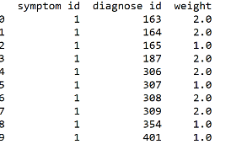

5. The elements of the ‘weight’ column was given in numbers but each number had its own meaning. Hence it was necessary to rename them according to the type of disease it implied.

The data before cleaning:

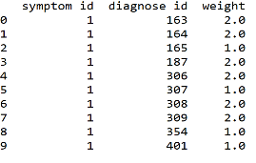

def colu(g):
if g==1.0:
s='common'
return s

elif g==2.0:
s='life-threatening'
return s

elif g==3.0:
s='common-paediatrics'
return s

df['weight']=df['weight'].apply(lambda x:colu(x))
The data after cleaning:

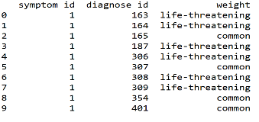

Analysing the data based on various parameters

1. Types of diseases (by weight):

grp = df.groupby('weight')
temp = grp['weight'].count()
temp.plot(kind = "pie",autopct="%0.2f%%")

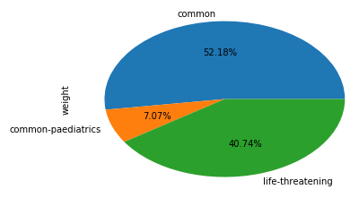

Inference: Most of the symptom – disease combinations in the dataset are of ‘common’ type.

2. The most common symptom:

grp = df.groupby("symptom id")
top = grp['weight'].count().sort_values(ascending = False)
print(sym[sym['symptom id']==(top == top.max).argmax()])

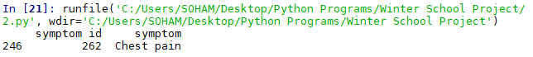

Inference: Chest pain is the most common symptom within the given data.

3. The disease with the maximum number of symptoms:

grp = df.groupby("diagnosis id")
top = grp['weight'].count().sort_values(ascending = False)
print(dia[dia['diagnosis id']==(top == top.max).argmax()])
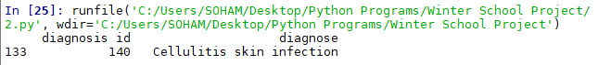
Inference: Cellulitis skin infection has the maximum number of symptoms.

4. Chances of chest pain to be life threatening:
grp = df.groupby("symptom id")
toplist = grp['weight'].count().sort_values(ascending = False)
top = (toplist == toplist.max).argmax()
topsym = grp.get_group(top)
grp = topsym.groupby('weight')
toplist = grp['weight'].count()
toplist.plot(kind = 'pie',autopct = '%0.2f%%')
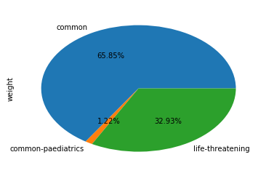

Inference: In most cases (approx. 66% times) chest pain is non life threatening.

5. Chances of chest pain to be related to some heart problems:

grp = df.groupby("symptom id")
toplist = grp['weight'].count().sort_values(ascending = False)
top = (toplist == toplist.max).argmax()
chestpain = grp.get_group(top)
tempdf = pd.DataFrame()
for i,row in chestpain.iterrows():
tempdf = tempdf.append(dia[dia['diagnosis id']==row['diagnosis id']])
c = 0
nc = 0
for i,row in tempdf.iterrows():
res1 = re.search('[Hh]eart',row['diagnose'])
res2 = re.search('[Cc]ardiac',row['diagnose'])
if res1 or res2:
c +=1
else:
nc+=1
print(nc)
ls = pd.Series({'heart problem':c,'not heart problem':nc})
ls.plot(kind = 'pie',autopct = "%0.2f%%")

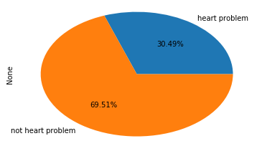

Inference: 70% of chest pain cases are not related to heart problems.

6. Symptoms of cellulitis skin infection (the disease with the most number of symptoms):

grp = df.groupby("diagnosis id")
toplist = grp['weight'].count().sort_values(ascending = False)
top = (toplist == toplist.max).argmax()
cellulitis = grp.get_group(top)
tempdf = pd.DataFrame()
for i,row in cellulitis.iterrows():
tempdf = tempdf.append(sym[sym['symptom id']==row['symptom id']])
print(tempdf)

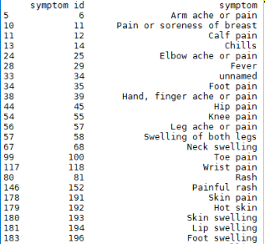

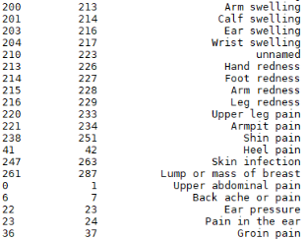

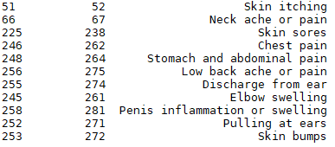

Inference: The list given above depicts the symptoms of cellulitis skin infection.

7. Classification of head ache:

tempdf = pd.DataFrame()
for i,row in sym.iterrows():
res = re.search('[Hh]eadache',row['symptom'])
if res:
tempdf = tempdf.append(row)
newdf = pd.DataFrame()
for i,row in tempdf.iterrows():
newdf = newdf.append(df[df['symptom id']==row['symptom id']])
tempdf = pd.DataFrame()
for i,row in newdf.iterrows():
tempdf = tempdf.append(dia[dia['diagnosis id']==row['diagnosis id']])
m,t,o,e,f = 0,0,0,0,0
for i,row in tempdf.iterrows():
res1 = re.search('[Mm]igraine',row['diagnose'])
res2 = re.search('[Tt]umor',row['diagnose'])
res3 = re.search('[Ee]ye',row['diagnose'])
res4 = re.search('[Ff]ever',row['diagnose'])
res5 = re.search('[Ii]nfluenza',row['diagnose'])
res6 = re.search('[Ii]nfection',row['diagnose'])
if res1:
m+=1
elif res2:
t+=1
elif res3:
e+=1
elif res4 or res5 or res6:
f+=1
else:
o+=1
ser = pd.Series({'Migraine': m,'Tumor': t,'Eye Problems':e,\
'Fever, Influenza and other infections':f, 'Others': o})
ser.plot(kind = 'pie',autopct = '%0.2f%%')

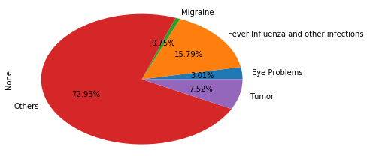

Inference: The pie chart given above shows the various causes of head ache.

8. Most problematic form of cancer (toughest to detect):

tempdf = pd.DataFrame()
for i,row in dia.iterrows():
res = re.search('[Cc]ancer',row['diagnose'])
if res:
tempdf = tempdf.append(row)
newdf = pd.DataFrame()
for i,row in tempdf.iterrows():
newdf = newdf.append(df[df['diagnosis id']==row['diagnosis id']])
grp = newdf.groupby('diagnosis id')
req = grp['diagnosis id'].count().sort_values()
result = pd.DataFrame()
for i in req.index:
if(req[i]==req.min()):
result = result.append(dia[dia['diagnosis id'] == i])
else:
break
print(result)

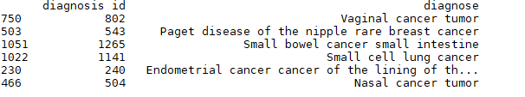

Inference: The types of cancer shown above are more difficult to detect because they have the lowest number of symptoms.

9. Silent Heart Diseases (with the lowest number of symptoms):

tempdf = pd.DataFrame()
for i,row in dia.iterrows():
res1 = re.search('[Hh]eart',row['diagnose'])
res2 = re.search('[Cc]ardi[(ac)o]',row['diagnose'])
if res1 or res2:
tempdf = tempdf.append(row)
newdf = pd.DataFrame()
for i,row in tempdf.iterrows():
newdf = newdf.append(df[df['diagnosis id']==row['diagnosis id']])
grp = newdf.groupby('diagnosis id')
req = grp['diagnosis id'].count().sort_values()
result = pd.DataFrame()
for i in req.index:
if(req[i]==req.min()):
result = result.append(dia[dia['diagnosis id'] == i])
else:
break
print(result)
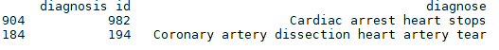

Inference: The above mentioned heart diseases have the lowest number of symptoms. Hence they are tougher to detect and silently affect a persons health.

10. Symptoms of appendicitis:

for i,row in dia.iterrows():
res = re.search('[Aa]ppendicitis',row['diagnose'])
if res:
grp = df.groupby('diagnosis id')
appendicitis = grp.get_group(row['diagnosis id'])
tempdf = pd.DataFrame()
for i,row in appendicitis.iterrows():
tempdf = tempdf.append(sym[sym['symptom id']==row['symptom id']])
print(tempdf)

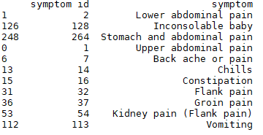

Inference: The list given above shows the symptoms of appendicitis.

11. Most common life threatening symptoms:

grp = df.groupby('weight')
tempdf = grp.get_group('life-threatening')
grp = tempdf.groupby('symptom id')
temp = grp['symptom id'].count().sort_values(ascending = False)
tempdf = pd.DataFrame()
for i in temp.index:
tempdf = tempdf.append(sym[sym['symptom id']==i])
temp.head(10).plot(kind='bar')
print(tempdf.head(10))
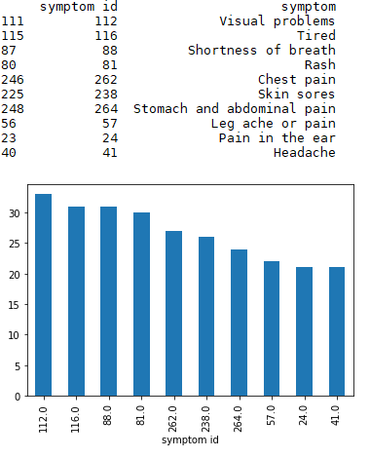

Inference: The list presents the 10 most common symptoms of life threatening diseases.

12. Life threatening diseases with the maximum number of symptoms:

grp = df.groupby('weight')
tempdf = grp.get_group('life-threatening')
grp = tempdf.groupby('diagnosis id')
temp = grp['diagnosis id'].count().sort_values(ascending = False)
tempdf = pd.DataFrame()
for i in temp.index:
tempdf = tempdf.append(dia[dia['diagnosis id']==i])
temp.head(10).plot(kind='bar')
print(tempdf.head(10))
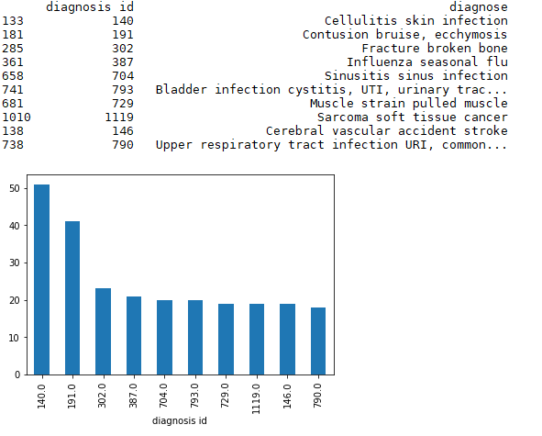

Inference: The list presents the top ten life threatening diseases with the maximum number of symptoms.

13. Common diseases with the maximum number of symptoms:

grp = df.groupby('weight')
tempdf = grp.get_group('common')
grp = tempdf.groupby('diagnosis id')
temp = grp['diagnosis id'].count().sort_values(ascending = False)
tempdf = pd.DataFrame()
for i in temp.index:
tempdf = tempdf.append(dia[dia['diagnosis id']==i])
temp.head(10).plot(kind='bar')
print(tempdf.head(10))

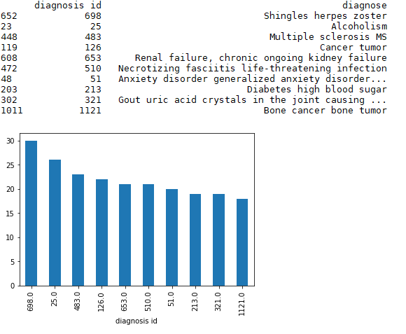

Inference: The list presents the top ten common diseases with the maximum number of symptoms.

14. Most common symptoms of non-lethal diseases:

grp = df.groupby('weight')
tempdf = grp.get_group('common')
grp = tempdf.groupby('symptom id')
temp = grp['symptom id'].count().sort_values(ascending = False)
tempdf = pd.DataFrame()
for i in temp.index:
tempdf = tempdf.append(sym[sym['symptom id']==i])
temp.head(10).plot(kind='bar')
print(tempdf.head(10))
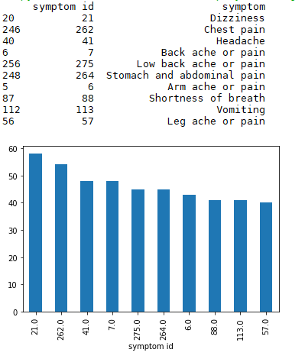

Inference: The list presents the 10 most common symptoms of common diseases.

15. Common-paediatric diseases with the maximum number of symptoms:

grp = df.groupby('weight')
tempdf = grp.get_group('common-paediatrics')
grp = tempdf.groupby('diagnosis id')
temp = grp['diagnosis id'].count().sort_values(ascending = False)
tempdf = pd.DataFrame()
for i in temp.index:
tempdf = tempdf.append(dia[dia['diagnosis id']==i])
temp.head(10).plot(kind='bar')
print(tempdf.head(10))
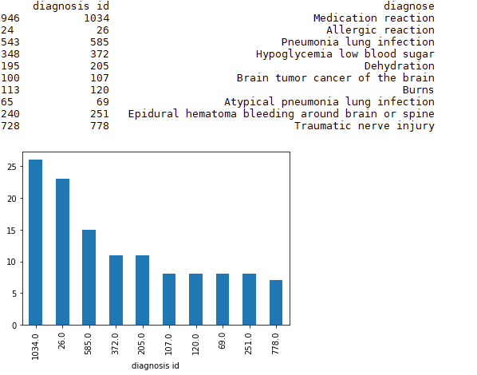

Inference: The list presents the top ten common paediatric diseases with the maximum number of symptoms.

16. Most common symptoms of paediatric diseases:

grp = df.groupby('weight')
tempdf = grp.get_group('common-paediatrics')
grp = tempdf.groupby('symptom id')
temp = grp['symptom id'].count().sort_values(ascending = False)
tempdf = pd.DataFrame()
for i in temp.index:
tempdf = tempdf.append(sym[sym['symptom id']==i])
temp.head(10).plot(kind='bar')
print(tempdf.head(10))

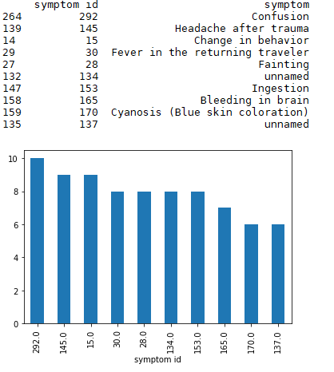

Inference: The list presents the 10 most common symptoms of common-paediatric diseases.

17. Diagnosis of drug abuse:

temp = pd.DataFrame()
for i,row in sym.iterrows():
res = re.search('[Dd]rug',row['symptom'])
if res:
temp = temp.append(row)
tempdf = pd.DataFrame()
for i in temp['symptom id']:
tempdf = tempdf.append(df[df['symptom id']==i])
temp = pd.DataFrame()
for i in tempdf['diagnosis id']:
temp = temp.append(dia[dia['diagnosis id']==i])
print(temp)

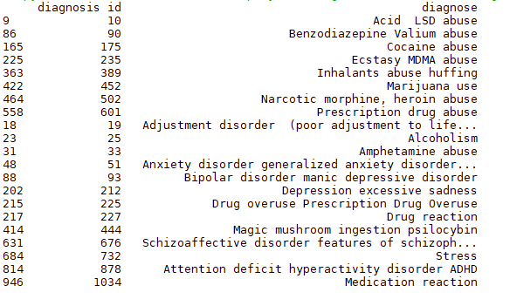

Inference: The list presents the diagnoses of drug abuse.

18. Types of diseases caused by drug abuse:

temp = pd.DataFrame()
for i,row in sym.iterrows():
res = re.search('[Dd]rug',row['symptom'])
if res:
temp = temp.append(row)
tempdf = pd.DataFrame()
for i in temp['symptom id']:
tempdf = tempdf.append(df[df['symptom id']==i])
print(tempdf)
grp = tempdf.groupby('weight')
count = grp['weight'].count()
count.plot(kind = 'pie',autopct = '%0.2f%%')

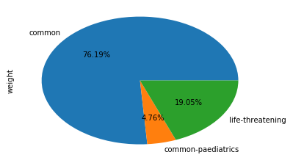

Inference: 19.05% of drug abuse diagnoses are life threatening.

19. Life threatening conditions caused by drug abuse:

temp = pd.DataFrame()
for i,row in sym.iterrows():
res = re.search('[Dd]rug',row['symptom'])
if res:
temp = temp.append(row)
tempdf = pd.DataFrame()
for i in temp['symptom id']:
tempdf = tempdf.append(df[df['symptom id']==i])
grp = tempdf.groupby('weight')
lt = grp.get_group('life-threatening')
temp = pd.DataFrame()
for i in lt['diagnosis id']:
temp = temp.append(dia[dia['diagnosis id']==i])
print(temp)
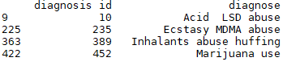

Inference: The list shows the life threatening conditions caused by drug abuse.

20. Effects of alcohol abuse:

temp = pd.DataFrame()
for i,row in sym.iterrows():
res = re.search('[Aa]lcohol',row['symptom'])
if res:
temp = temp.append(row)
tempdf = pd.DataFrame()
for i in temp['symptom id']:
tempdf = tempdf.append(df[df['symptom id']==i])
temp = pd.DataFrame()
for i in tempdf['diagnosis id']:
temp = temp.append(dia[dia['diagnosis id']==i])
print(temp)
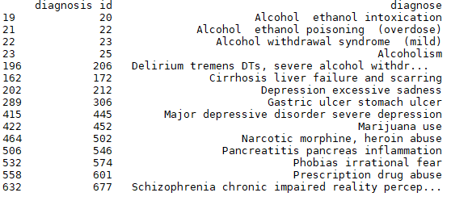

Inference: The list shows the effect of alcohol abuse.

Future Scope of Improvements

The analysis of this disease data can further be improved by implementing machine learning models and using predictive analytics. The above mentioned concepts can be used to predict symptoms or diagnosis for given cases.

